**TASK 2**

To Test the webpages using Jasmine for the modules

Code

const {Builder, By, Key, until} = require('selenium-webdriver');

// You can use a remote Selenium Hub, but we are not doing that here

require('chromedriver');

const driver = new Builder()

.forBrowser('chrome')

.build();

jasmine.DEFAULT_TIMEOUT_INTERVAL = 20 * 1000;

describe('Selenium test case for login page', () => {

it('Should navigate to Demo Page', async function() {

await driver.get('https://www.urbanladder.com/');

await driver.getCurrentUrl().then((url) => {

expect(url).toBe('https://www.urbanladder.com/');

driver.manage().window().maximize();

});

});

it('title check',async function(){

expected = "Furniture Online: @Upto 40% Off on Wooden Furniture Online in India at Best Price - Urban Ladder";

actual =await driver.getTitle();

console.log(actual);

expect(actual).toBe(expected);

});

it('login',async function(){

var s1=driver.findElement(By.xpath("/html/body/div[1]/header/div[1]/div/section[3]/ul/li[2]/span"));

await s1.click();

var s2=driver.findElement(By.partialLinkText("Log In"));

await s2.click();

await driver.sleep(3000);

await driver.findElement(By.xpath("/html/body/div[6]/div/div[1]/div/div[2]/div[3]/form/div/input")).sendKeys( "harimurali007@gmail.com");

await driver.findElement(By.xpath("/html/body/div[6]/div/div[1]/div/div[2]/div[3]/form/div/div/div/input")). sendKeys("harimurali007");

await driver.findElement(By.id("ul_site_login")).click();

});

it('bed',async function(){

await driver.findElement(By.xpath("/html/body/div[1]/header/div[2]/div/nav/div/ul/li[3]/span")).click();

var rd= await driver.findElement(By.partialLinkText('Bed'));

let data=await rd.getText();

console.log(data);

// expect(data).toBe('Bed');

});

it('matteress',async function(){

await driver.findElement(By.xpath("/html/body/div[1]/header/div[2]/div/nav/div/ul/li[3]/span")).click();

var rd= await driver.findElement(By.partialLinkText('Mattresses'));

let data=await rd.getText();

console.log(data);

//expect(data).toBe('Mattresses');

});

it('Storage & Accessories',async function(){

await driver.findElement(By.xpath("/html/body/div[1]/header/div[2]/div/nav/div/ul/li[3]/span")).click();

var rd= await driver.findElement(By.partialLinkText('Storage & Accessories'));

let data=await rd.getText();

console.log(data);

expect(data).toBe('Storage & Accessories');

});

it('Kids Bedroom',async function(){

await driver.findElement(By.xpath("/html/body/div[1]/header/div[2]/div/nav/div/ul/li[3]/span")).click();

var rd= await driver.findElement(By.partialLinkText('Kids Bedroom'));

let data=await rd.getText();

console.log(data);

expect(data).toBe('Kids Bedroom');

});

it('Bed Click',async function(){

await driver.findElement(By.xpath("/html/body/div[1]/header/div[2]/div/nav/div/ul/li[3]/span")).click();

await driver.findElement(By.partialLinkText('Double Beds')).click();

});

it('filter',async function(){

await driver.findElement(By.xpath("/html/body/div[2]/div[2]/div[3]/div[2]/div[1]/div/form/div[1]/div/div/ul/li[1]/div[1]")).click();

await driver.findElement(By.xpath("/html/body/div[2]/div[2]/div[3]/div[2]/div[1]/div/form/div[1]/div/div/ul/li[1]/div[2]/div/div/ul/li[2]/div[1]/label/input")).click();

});

});

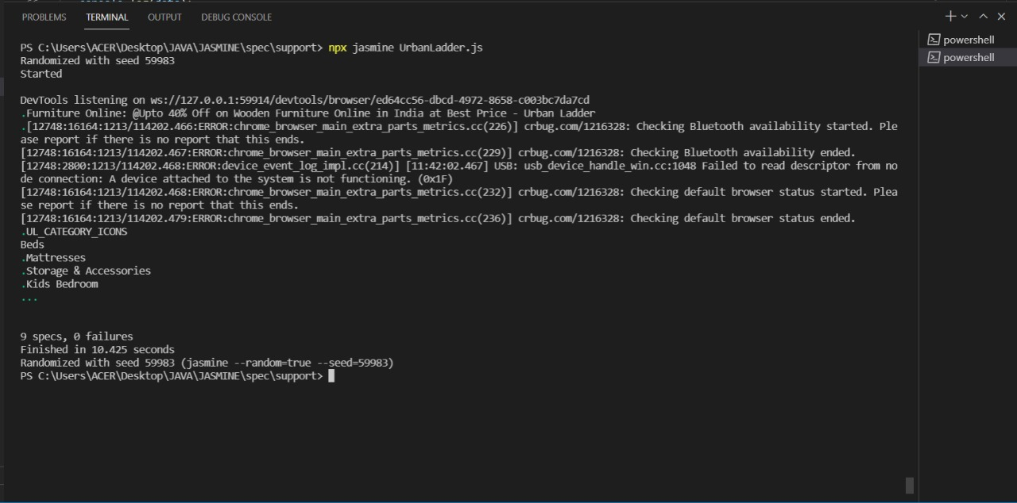**RESULTS**